Project 5: Urine Cultures and Identification
Readings:
- http://www.webmd.com/a-to-z-guides/Urine-Culture
- http://www.medscape.com/viewarticle/558845 (Listen to the two lectures by Dr. Robert A. Weinstein.)

Identification of Gram-Positive & Gram-Negative Bacteria:
- Guide to laboratory stock cultures developed during Lab Project 4

Purpose:
The purpose of this experiment is for students to understand microbe identification in the context of a clinical situation. This lab uses the clinical simulation of the urine culture to more precisely define the process of determining the genus and species identification of a potential pathogen from a clinical specimen.

Outcomes:
After you complete this lab, you will be able to:
- Isolate and identify bacteria in an unknown sample.
- Perform a quantitative streak plate.
- Make decisions about the type of tests that must be performed to confirm the genus and species of an unknown bacterium using the methods of colony morphology (using TSY), differential staining (Gram, Acid-fast, Endospore), differential and selective media (blood agar, mannitol salt, MacConkeys), and more specific laboratory tests.
- Perform the tests, collect and interpret the data.
- Relate urinary tract anatomy and potential urinary tract pathogens.
- Identify sterile sites in the healthy urinary tract.
- Identify sites potentially contaminated with normal flora.
- Distinguish between a contaminant and a urinary pathogen.
- Evaluate the impact of specimen collection on microbial assay and interpretation.
  - Compare the microbial identification of clinically significant microbes to the representative groups used in this student lab.
- Perform and interpret antibiotic sensitivity testing.
  - Identify the time necessary for performing the test.
  - Identify limitations of sensitivity testing.
  - Relate microbial structure to mode of anti-microbial action.

Terms to Know:

Be able to define these terms and apply them in the laboratory.
10-1, 10-2, 10-3, 10-4, etc. | distal | Polymerase Chain Reaction
<100,000 colonies/mL | electrophoresis | Polymerase
>100,000 colonies/mL | enteric bacteria | quantitate
antibiotic sensitivity | Enterobacteriaceae | selective media
API 20E | Enterococcus | serial dilution
Bacitracin sensitivity | MacConkey’s medium | sterile specimen
calibrated loop | medical technologist | Taq
clean catch | mode of action | threshold
coliform | Nitrogenous base | urethra
colony forming unit | proximal | viable cell counts
differential media

Urine Cultures & Identification – SESSION 1
INTRODUCTION:
To gain familiarity with urine culture, you will be given a “patient’s urine” (one of the lab strains in broth culture) to investigate. After you have plated your unknown, as if it were a clinical urine sample, and evaluated those results, you will identify your unknown. You will use decision making by employing the key you established at the end of Lab Project 4. The techniques of differential staining and the use of differential and selective media will allow you to find the genus and species identification of your assigned unknown bacterium. In addition to the identifying tests you will learn to perform an antibiotic sensitivity tests and report the results.
Colony Counts
Colony counts provide a way to determine the number of viable microbial cells in a given specimen. One colony on a Petri plate represents one viable cell (one colony-forming unit) from the sample. The viable cell, once inoculated on the medium, divides by binary fission to form two cells. Each of the resulting cells continue to divide by binary fission (2 to 4; 4 to 8; 8 to 16; and so on) until a colony can be observed (at least a million cells must be present in order to be seen as a colony with the naked eye!). We report our results in terms of the number of bacterial cells per mL of urine.
To calculate this, we culture a small amount of the urine and then use unit analysis. For example, if we spread 0.1 mL of urine onto the plate and 100 colonies grow, this means there were 100 viable cells in 0.1 mL of the urine, which is the same as 1,000 viable cells in 1 mL of urine. Here’s the math:
.
Dilutions
In many samples, millions or billions of bacteria are present. When plated, even a small sample would give rise to so many colonies that they would run together and be hard to count. What is usually done is to plate a series of dilutions of the sample. You can always take the dilution factor into account when calculating the number of cells in the original sample. By doing a series of dilutions, you insure that one of the dilutions will give you colony numbers that are not too high or too low, but just right. You may use this serial dilution technique in later labs. A variant of this technique is to plate only a very small known amount of the sample on a plate.
Calculating Our Sample Dilutions
Since results are reported in cells/mL, the colony number in this case must be multiplied by the reciprocal of the fraction of sample plated. For example, if 0.001 mL (1 microliter, abbreviated as 1 μl) is plated, the colony number must be multiplied by 1000, since 0.001 mL is 1/1000th of a mL. This serial dilution technique is used when the investigator has no idea how many bacterial cells are present. Plating serial dilutions increases the chance of (1) quantitating the bacteria and (2) isolating colonies of the different types of bacteria present.
In the clinical laboratory, this principle is applied to the microbial assay of urine. A urine sample is streaked on medium using a special inoculating loop known as a “calibrated loop.” The calibrated loop is calibrated so that it picks up only 0.001 mL of urine from the patient’s specimen. Thus, while no actual dilution is done, only a small volume (one microliter) is streaked onto a plate. When reading the results of the urine culture, the medical technologist takes into account that only 0.001 mL was plated, multiplies the results by 1000 and reports “colonies/mL.”
Urine Sample Contamination
Although we would expect fluid stored in the bladder to be sterile, it must pass through the urethra as it exits the body. The distal portion of the urethra is colonized by normal flora. As the urine passes through this region, some of the normal flora gets caught up in the flow. Therefore, we would expect to find some bacteria in urine. The medical microbiologist must determine if the bacteria in a urine sample indicate a urinary tract infection (UTI). Complicating matters is that most of the bacteria that cause UTIs are part of the normal flora of the intestinal tract, likely the same ones that normally inhabit the distal portion of the urethra.
Threshold Bacterial Count Required to Suspect UTI
In the clinical lab, 0.001-mL urine samples are streaked on two media, TSY and MacConkey’s, and incubated at 37° C for 24 hours. At the end of the incubation period, the medical technologist counts the number of colonies on the TSY plate. (Each colony represents 1000 cells present in the original specimen. Why?) If the technologist counts 30 colonies on the plate, there were 30 cells in the 0.001 mL plated. This 0.001 mL is one-thousandth of a mL, so to calculate the number of cells per mL of the original urine sample, the technologist multiplies 30 colonies in 1/1000th mL x 1000 = 30,000 cells per mL of the original urine sample. The threshold (the minimum number of cells that must be present in order to suspect a UTI) is 100,000 cells/mL. Thus, a urine TSY plate with more than 100 colonies on it represents an original urine sample with more than 100,000 bacterial cells per mL. This far exceeds the number that can be picked up from the distal urethra. The bacteria are assumed to have come from the bladder and represent the organism causing the UTI.
Having > 100,000 cells/mL is the first criterion for a urinary tract infection. The second criterion is that the colonies must be all one type. If these 2 criteria are met, the culture is slated for further “work-up.” A work-up involves the isolation of the potential pathogen, biochemical identification of the microbe’s genus and species and an antibiotic sensitivity test.

PROCEDURE:
1. Obtain a urine ‘unknown’ from your instructor. Record the unknown identification number.
2. Obtain a sterile TSY, and MacConkey’s plate.
3. Use the sterile, green plastic inoculating loop (which is calibrated to transfer 0.001 mL) to transfer 0.001 mL of urine from the urine specimen to your second TSY plate. Touch the loop initially in the center of the plate, and then spread the inoculum in a line across the diameter of the plate (Figures 5-1 and 5-2).
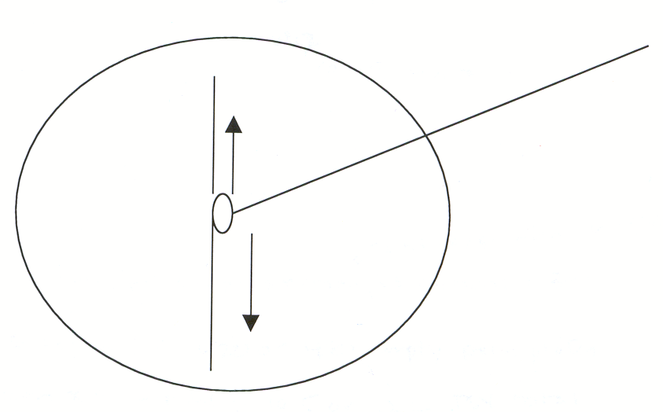
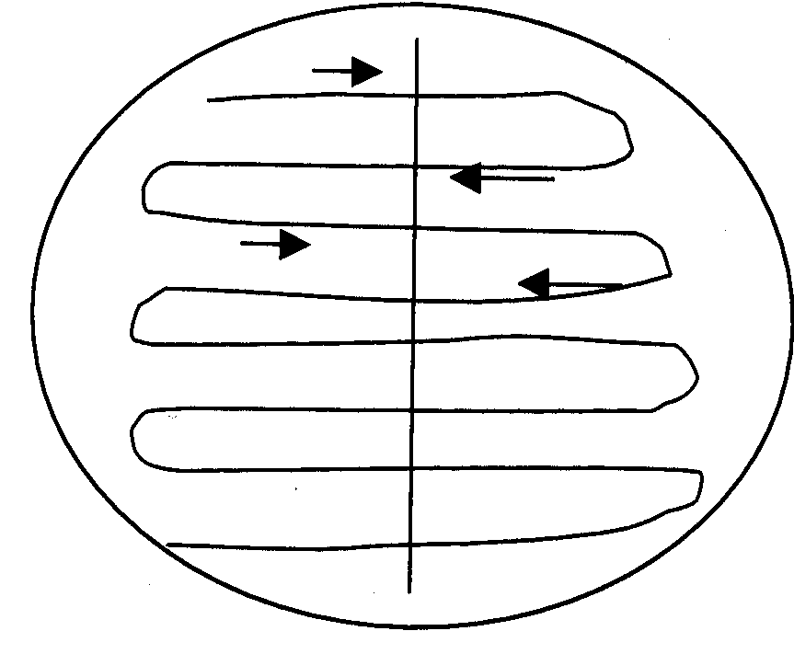
Figure 5-1: Initial Inoculation of Urine on Media
Figure 5-2: Distribution of Initial Streak of
Urine on Media Plates

7. Then, without flaming the loop, inoculate the rest of the medium as demonstrated.
6. Repeat steps 3 and 4 on the MacConkey’s agar plate from your unknown
urine specimen.
7. Label your plates with your initials, unknown number or patient name, the date, and place them in the incubation bin. They will be incubated at 37°C for 24 hours. You will read the results the next session.

*Use of the calibrated loop and the streaking pattern above is called a quantitative streak plate (in contrast to the isolation streak plate that you have done in the past). Whereas the goal of an isolation streak plate is merely to achieve isolated colonies, the goal of a quantitative streak plate is to ultimately be able to count the number of colonies on your plate.

Urine Cultures & Identification – SESSION 2
INTRODUCTION:
Last session, you plated out your unknown urine sample on TSY and MacConkey's agars. Today you will determine if your sample indicates the presence of a urinary tract infection, and if so, you will proceed to identify the agent. Two criteria must be satisfied in order to confirm the presence of a bacterial cause of a UTI:
1. There must be more than 100,000 colonies per mL of urine on the TSY plate, and …
2. There must be only one colony morphology present.

In clinical labs, whenever the criteria for a urinary tract infection (UTI) are met, a work-up follows. The genus and species of the bacterium are determined, and an antibiotic sensitivity assay is performed. After you have evaluated your sample as if it were a clinical urine sample, you will proceed to identify the bacterium. Your instructor will help you determine whether you will proceed with identification as in the previous lab. If this is the case, consider your dichotomous key (developed in Lab Project #4) and determine the appropriate course of action. Set up the appropriate tests, and where necessary, save the plates and assays in the green “save” bin. They will be incubated and stored until the next session, when you read the results

Antibiotic Sensitivity
We will use the Kirby Bauer Method of antibiotic sensitivity. In this technique, a carpet of growth of bacteria is promoted on TSY media. Antibiotic discs are applied to the inoculated media before incubation. Each disc is impregnated with a different antibiotic. The antibiotics diffuse from the disc through the TSY media. As they get farther from the disc their concentration decreases. If the bacteria are sensitive to the antibiotic they will not be able to grow around the disc at a particular concentration. The resulting circular pattern where no growth of bacteria occurs is called the zone of inhibition. The zone is based on many factors and may vary from antibiotic to antibiotic. Thus, a table of zone sizes, acquired from the antibiotic disc suppliers is provided so that you can interpret your results:
Antibiotic | Sensitive | Resistant
penicillin | > 29 mm | < 28 mm
erythromycin | > 18 | < 13
ciprofloxacin | > 18 | < 12
tetracycline | > 19 | < 14
methicillin | > 17 | < 12
sulfadiazine | > 16 | < 10

Notice that sometimes the numbers provided leave a gap. For instance, there is a gap between 13 and 18 mm when interpreting the results of the erythromycin antibiotic. This gap can be interpreted as neither sensitive or resistant, but rather an ‘intermediate’ sensitivity.

PROCEDURE:
Urine Culture & Identification
- Obtain the urine culture plates set up in Session 2.
- Record the number of colonies and the number of colony morphologies you observe. Determine if these observations are consistent with a urinary tract infection. If so, complete the ‘work up’.
- Work up of a potential pathogen from urine culture:
- Recall that the first step in identification of an unknown is the Gram stain. Complete this test, record your data, and interpret the results. You will need to include these data in your Patient Work-Up form, including pictures. Record your observations (i.e. purple, round, etc.) and interpretations (Gram positive, cocci) in the separate columns provided.
- Using your Gram stain as a guide, determine the identification tests you need to set up for identification of the bacterium. The dichotomous key and previous laboratory experience provides the basis for this decision-making. Acquire the necessary media/reagents, set up the tests. Place the tests in the appropriately labeled green incubation bin for incubation and storage until next week.
Some decision making guides are as follows:
- Use positive test results as your definitive test (e.g “I see endospores therefore, given the known laboratory stock bacteria, I know I have identified Bacillus subtilis”) rather than a negative test (e.g. “I do not see endospores on the endospore stain and the only other possible Gram positive bacilli is Mycobacterium smegmatis”).
- Set up identifying tests AND the antibiotic sensitivity tests (procedure below) during Session 2 of the lab. Read all of your results during Session 3.
- Record your OBSERVATIONS and your INTERPRETATIONS in your Patient Work-up Form).
- Identify your unknown (genus and species identification).
NOTE: If you set up a test that is not needed, you will be charged (penalty points will be deducted from your work-up) for excess use of materials. If the work-up is not completed in a timely manner because you did not set up appropriate tests in the correct order, you will be charged with an ethics violation (penalty points assessed) because you caused a patient to suffer due to improper decision making. You have a classroom full of colleagues. Use this fertile ground for discussion of what you plan to do and why you think it should be done this way.

Antibiotic Sensitivity Testing Procedure
Set up antibiotic sensitivity test using the following modified Kirby Bauer technique:
1 Obtain 3 TSY plates for testing antibiotic sensitivity. One of the three will be used as a heat sink.
2. Identify several well-isolated colonies from a pure culture isolation streak plate of your unknown.
a. Pick these colonies using a sterile cotton swab.
b. Transfer the colonies to a tube of 10 mL of sterile saline. Squeegee the cotton swab on the side of the test tube to dislodge the bacterial colonies and make a cloudy suspension.
c. Discard the cotton swab in the biohazard bag.
3. Use a Pasteur pipette to mix your suspension.
4. Place 5 drops of your bacterial suspension on each of your TSY plates.
5. Using a spreader, spread the bacteria over the surface of the TSY plates.
a. Pour enough ethanol into a beaker so that the end of the spreader is immersed in the alcohol when dipped.
b. Dip your spreader in alcohol, and then flame. Be sure there is no paper on the lab bench near the Bunsen burner, so if the flaming alcohol drips, you do not light it on fire.
c. Wait until no flame is visible, and then touch the flamed spreader to the surface of your heat sink TSY plate to cool it. You are using the heat sink to disperse the heat from flaming from the spreader more rapidly than if you waited for it to cool in air.
d. Use the spreader to spread the bacteria on the two plates you will use for antibiotic testing.
6. Located on the side bench you will find Petri plates containing antibiotic disc cylinders. You will need penicillin, methicillin, tetracycline, ciprofloxacin, sulfadiazine and erythromycin. Write down the letters on the disks (or on your plate’s under-surface, under the discs and agar) and the names of the corresponding antibiotics so you will be able to interpret your results next week. You will need at least one chrome disc-dispenser. Dispense three disks onto each plate, being careful to keep them as far apart as possible from each other and from the edge of the plate (equidistant), so your zones of inhibition don’t run together.
7. Sterilize a loop, and gently touch it to each disk to be sure the disc adheres to the surface of the medium. Don’t push the disc into the media. Gently tap the disc and it will adhere.
8. Place your test plates in the green “save” bin. Discard your heat sink.

Urine Cultures & Identification – SESSION 3
Urine Culture & Identification
Evaluate the results of the bacterial identification test you set up in Session 2 and record these results on your Patient Work-up Form.
Antibiotic Sensitivity
- Retrieve the antibiotic sensitivity plates from the bin.
2. Identify antibiotics that lack a zone of inhibition, and record the result as “No zone of inhibition”.
3. Identify antibiotic discs encircled by a zone of inhibition (Figures 5-3 & 5-4).
a. Place the edge of the metric ruler on the back of the bottom of the TSY plate so that the zero hash mark is lined up with one edge of the zone.
b. Measure the diameter of the zone in millimeters through the middle of the disc, and record the result in the second table that follows.
c. Use the Antibiotic Sensitivity Measurements table of you Patient Work-up Form to interpret your results. S = sensitive, R = resistant, I = intermediate sensitivity

Zone of Inhibition
No Zone of Inhibition
Figure 5-3: Antibiotic Discs on an Inoculated TSY Plate
Te
P
E

Antibiotic Discs

P
Te
E
Measure ZOI
n
Millimeters
Rulerrr

Figure 5-4: Measuring the Zone of Inhibition

