Immunology & Infectious Disease Homework Assignment
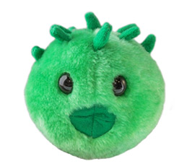

Name: _________________________________________

This is an opportunity to put together some of the knowledge that you have gained throughout the semester, prepare for the final exam, and earn points as well! Discuss all aspects of innate and acquired immunity that might be involved in a Chlamydia trachomatis infection. You learned about this microbe in the Meet the Microbes: Prokaryotes lecture (Your book will have additional information on C. trachomatis).

I expect a very detailed, accurate and precise answer for full credit. You may type your responses directly on this document and then print it (if you do, please italicize or highlight each answer to distinguish it from the question), or just print out this page the use additional paper if you wish. Make sure that this page, with your name, is stapled to the rest of your work.

- What type of microbe is C. trachomatis and how does it infect cells? Your answer will include information about its life cycle.

- Describe the barriers to infections that C. trachomatis would face in moving beyond the body’s first line of immune defense.

- Describe the barriers to infection that C. trachomatis would face in moving beyond the body’s second line of defense.

- How would the third line of defense recognize and try to deal with Chlamydia infection?

