Classroom Science Activity: Scientific Method
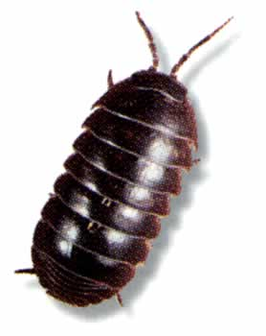

Name of Group Members:
___________________________________________________
___________________________________________________
___________________________________________________
___________________________________________________
___________________________________________________

You will be designing an experiment to help you to better understand the scientific method.
Break up into groups of between 3 and 5 members. Design an experiment to investigate the pillbugs’ response to light, pH, food, hiding place, background color, or suggest another variable to test. Choose only one variable to manipulate. Please clear your experiment with the instructor before your proceed.

You will be working through all of the steps of the scientific method:
- ask a question
- develop a hypothesis
- state the objectives of your experiment
- design your experiment (list materials that you will use, and outline your procedure in detail, determine what data you will collect)
- analyze your data
- draw a conclusion (was your hypothesis supported or not?)

- Select one of the environmental stimuli above and come up with a question that you want to answer regarding pillbug behavior.

______________________________________________________________________________________________________________________________________________________________________________________________________________________________________________________________________________________________________________________________________________________________________________________________________

- Develop a hypothesis concerning the pillbugs’ response to the stimulus that you have chosen.
______________________________________________________________________________________________________________________________________________________________________________________________________________________________________________________________________________________________________________________________________________________________________________________________________

- Use the materials available to design your experiment. Remember that you can only teat one stimulus (variable) at a time.

- State the objective of your experiment.
______________________________________________________________________________________________________________________________________________________

- List the materials that you will use: ________________________________________________________________________________________________________________________________________________________________________________________________________________________________________________________________________________________________________________________________________________________________________

- Outline your procedure in detail. Remember to vary only one stimulus.

__________________________________________________________________________________________________________________________________________________________________________________________________________________________________________________________________________________________________________________________________________________________________________________________________________________________________________________________________
HAVE YOUR INSTRUCTOR APPROVE THE EXPERIMENT BEFORE YOU BEGIN!

- In the space below, or on a separate sheet, create a data sheet to record your data.

- Run your experiment and record your observations on the data sheet.

- Examine data. You may want to total some data, or take averages, depending on how you designed your experiment. This will help you draw a conclusion from your experiment.

- Do the results of your experiment support or disprove your hypothesis? Explain why.
____________________________________________________________________________________________________________________________________________________________________________________________________________________________________________________________________________________________________________
PLEASE RETURN THE PILLBUGS TO THE STOCK CONTAINER THAT YOU ORIGINALLY RETREIVED THEM FROM.

