Eukaryotic Cell Diagram Homework Assignment

Name:________________________________________

Label the numbered structures of the eukaryotic cell below and provide a brief description of the function of each structure. You will not be asked to ID all parts, only those requested on the next page.

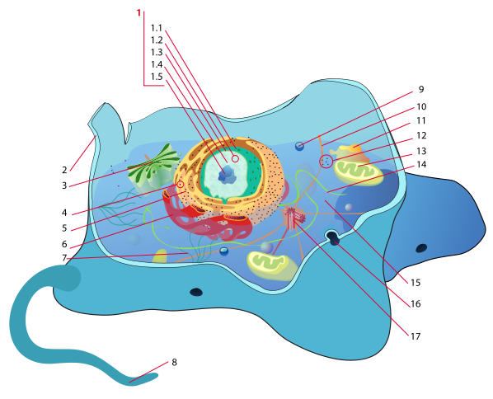

Image: Eukaryotic
Cell by Mariana Ruiz

Eukaryotic Cell Diagram Homework Assignment, p.2

Name:________________________________________

- ___________-_____________________________________________________________________

- plasma membrane - _________________________________________________________________

- __________________ -______________________________________________________________

- ___________________-_____________________________________________________________

- rough endoplasmic reticulum - ________________________________________________________

- ________________________-________________________________________________________

No # 7

8. ___________ - ________________________________________________________________

9. vesicle_-_____________________________________________________________________

- cyto__________-___________________________________________________________________

No # 11 or 12

- _________________ - ______________________________________________________________

No # 14

- cyto______ - ______________________________________________________________________

